Chaucer satire vocabulary for the unit (student copy)
Name:

Irony | --the expression of one's meaning by using language that normally signifies the opposite, typically for humorous or emphatic effect
Satire | --the use of humor, irony, exaggeration, or ridicule to expose and criticize
Sarcasm | --the use of irony to mock or convey contempt.
Parody | --an imitation of the style of a particular writer, artist, or genre with deliberate exaggeration for comic effect.
Ridicule | --the subjection of someone or something to contemptuous and dismissive language or behavior.
Epigram | --a short saying or remark expressing an idea in a clever and amusing way.
Sardonic | —grimly mocking or cynical
Caricature | --a picture, description, or imitation of a person or thing in which certain striking characteristics are exaggerated in order to create a comic or grotesque effect.
Farce | --a comic dramatic work using buffoonery and horseplay and typically including crude characterization and ludicrously improbable situations.
Facetious | --treating serious issues with deliberately inappropriate humor; flippant.
Self-deprecating | --joke about or critical of oneself, especially humorously so.
Tongue-in-cheek | --figure of speech is used to imply that a statement is not literal and actually humorous
Paradox | --a statement that is self-contradictory because it often contains two statements that are both true, but in general, cannot both be true at the same time.
Understatement | --the presentation of something as being smaller, worse, or less important than it actually is.
Hyperbole | --exaggerated statements or claims not meant to be taken literally.

Triangle Association
- Write one word in each corner of the triangle.
- Explain the relationship between each word.
- Feel free to be creative and use examples to illustrate your point.

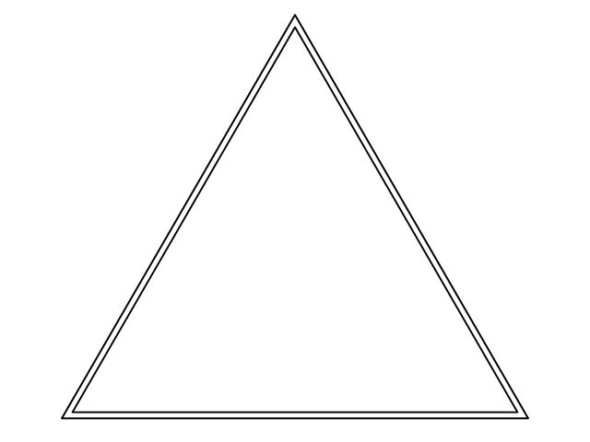

Activity #1 Quiz-Quiz-Pass
*I need a volunteer!

- You all have cut up slips of the vocabulary words.
- Hold up your word and have your partner guess.
- If they get it right, high five them.
- If they get it wrong, then show and read them the right answer. Then give them a high five.
- Then trade words with them and go onto someone else.

Activity #2—Draw or act
- Choose one of the vocabulary words
- Now, either make a drawing on the back of your notecard or think of how you would act out your vocabulary word.
- Take five minutes and be ready to present.
- When someone is going we should all guess

Activity #3—Zipper!

- Break off into two groups. This will be a race.
- Someone start asking “who has” a particular word reading the definition
- If you have the word that matches the definition, say you have that word.
- Then continue the “who has” chain until you all are done.

Activity #4—Pyramid
- Choose three of the vocabulary words
- Write each one at a corner of your pyramid
- Then, connect them in the spaces by explaining the relationship that you’ve created.
- This is tough! Feel free to be creative and use examples if that helps you illustrate your point.

Quiz-Quiz-Pass Copy
Irony | --the expression of one's meaning by using language that normally signifies the opposite, typically for humorous or emphatic effect
Satire | --the use of humor, irony, exaggeration, or ridicule to expose and criticize
Sarcasm | --the use of irony to mock or convey contempt.
Parody | --an imitation of the style of a particular writer, artist, or genre with deliberate exaggeration for comic effect.
Ridicule | --the subjection of someone or something to contemptuous and dismissive language or behavior.
Epigram | --a short saying or remark expressing an idea in a clever and amusing way.
Sardonic | —grimly mocking or cynical
Caricature | --a picture, description, or imitation of a person or thing in which certain striking characteristics are exaggerated in order to create a comic or grotesque effect.
Farce | --a comic dramatic work using buffoonery and horseplay and typically including crude characterization and ludicrously improbable situations.
Facetious | --treating serious issues with deliberately inappropriate humor; flippant.
Self-deprecating | --joke about or critical of oneself, especially humorously so.
Tongue-in-cheek | --figure of speech is used to imply that a statement is not literal and actually humorous
Paradox | --a statement that is self-contradictory because it often contains two statements that are both true, but in general, cannot both be true at the same time.
Understatement | --the presentation of something as being smaller, worse, or less important than it actually is.
Hyperbole | --exaggerated statements or claims not meant to be taken literally.

Zipper
I have Satire | Who has--the expression of one's meaning by using language that normally signifies the opposite, typically for humorous or emphatic effect?
I have Sarcasm | Who has --the use of humor, irony, exaggeration, or ridicule to expose and criticize?
I have Parody | Who has --the use of irony to mock or convey contempt?
I have Ridicule | Who has --an imitation of the style of a particular writer, artist, or genre with deliberate exaggeration for comic effect?
I have Epigram | Who has --the subjection of someone or something to contemptuous and dismissive language or behavior?
I have Sardonic | Who has --a short saying or remark expressing an idea in a clever and amusing way?
I have Caricature | Who has —grimly mocking or cynical?
I have Farce | Who has --a picture, description, or imitation of a person or thing in which certain striking characteristics are exaggerated in order to create a comic or grotesque effect?
I have Facetious | Who has --a comic dramatic work using buffoonery and horseplay and typically including crude characterization and ludicrously improbable situations?
I have Self-deprecating | Who has --treating serious issues with deliberately inappropriate humor; flippant?
I have Tongue-in-cheek | Who has --joke about or critical of oneself, especially humorously so?
I have Paradox | Who has --figure of speech is used to imply that a statement is not literal and actually humorous?
I have Understatement | Who has --a statement that is self-contradictory because it often contains two statements that are both true, but in general, cannot both be true at the same time?
I have Hyperbole | Who has --the presentation of something as being smaller, worse, or less important than it actually is?
I have Irony | Who has --exaggerated statements or claims not meant to be taken literally?

